**Celebration of May Day International Labor Day by Chambishi Wet Smelting and CNMC Luanshya, etc.**

To celebrate May Day International Labor Day, Chambishi Wet Smelting and CNMC Luanshya, enterprises in Zambia funded by the company, organized the 2018 Activity for Celebration of Labor Day on April 28 and May 1, 2018, Zambia local time.

This event of Chambishi Wet Smelting was jointly attended by the Chinese and Zambian employees from each department and workshop of the company. During the event, the company specially invited Zambia's Pamodzi Art Troupe to perform a wonderful national dance performance, also Chinese and Zambian staff performed their self-produced art program, which made the activity warm and relaxed. There were also a variety of entertainment activities such as tug-of-war competitions and stool-scrambling, which were well-received by the employees. This activity enhanced the teamwork sense and collaboration of employees. Over 200 Chinese and Zambian employees from various departments and workshops of the company participated in the event.

Mr. Zhang Peiwen, vice-president of the company and general manager of Chambishi Wet Smelting, attended the activity as well as awarded prizes and certificates to 9 excellent employees from China and Zambia, encouraging them to continue keeping hard work and doing good job of exemplary role in the future, promoting the development of Wet Smelting Company.

Enterprises such as CNMC Luanshya also organized celebrations.

。

(Submitted by: Liu Yongqing/Chambishi Wet Smelting, Pan Bin/CNMC Luanshya)

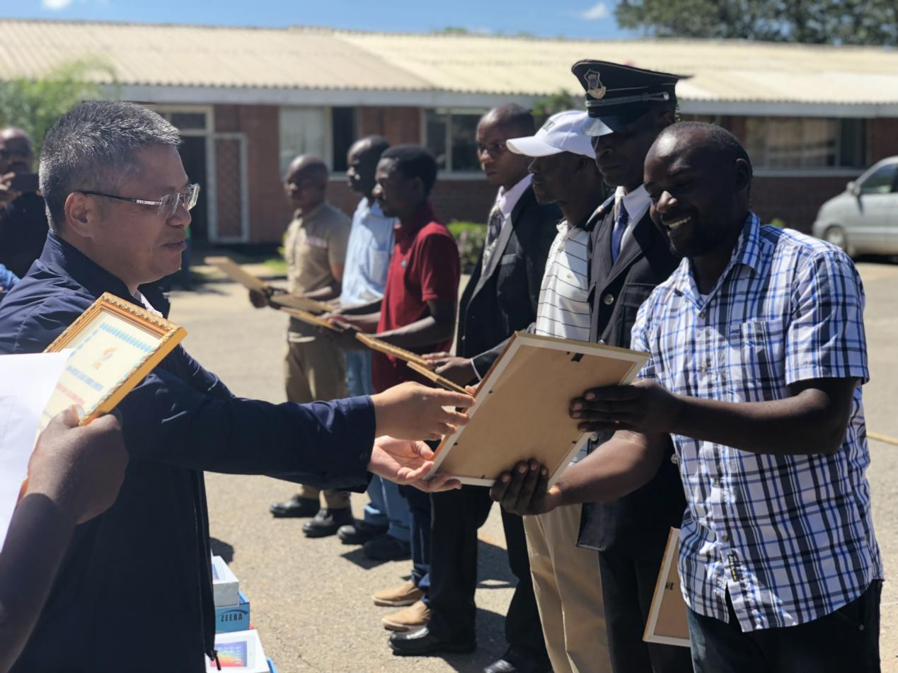

Mr. Zhang Peiwen, vice president of the company and general manager of Chambishi Wet Smelting, awards certificate to excellent employees.

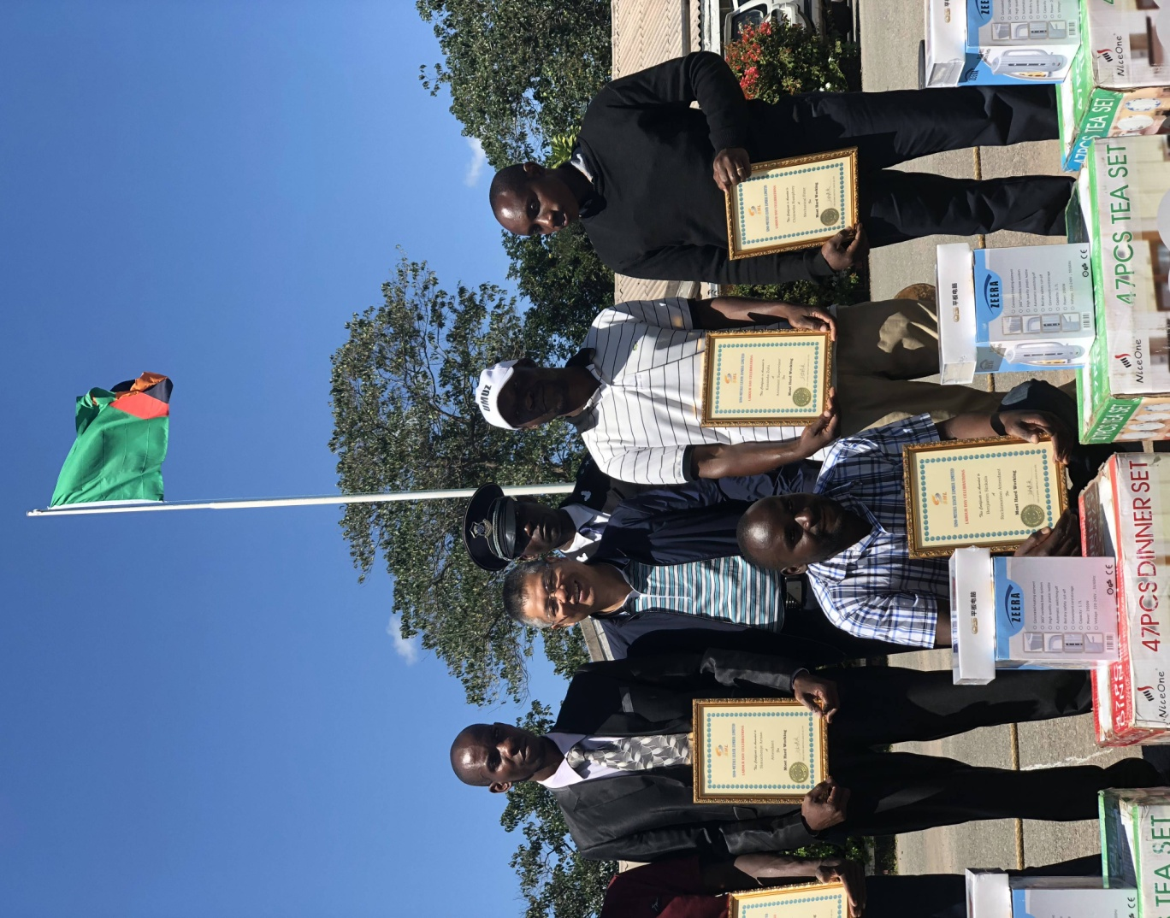

Group photo of Mr. Zhang Peiwen and excellent employees

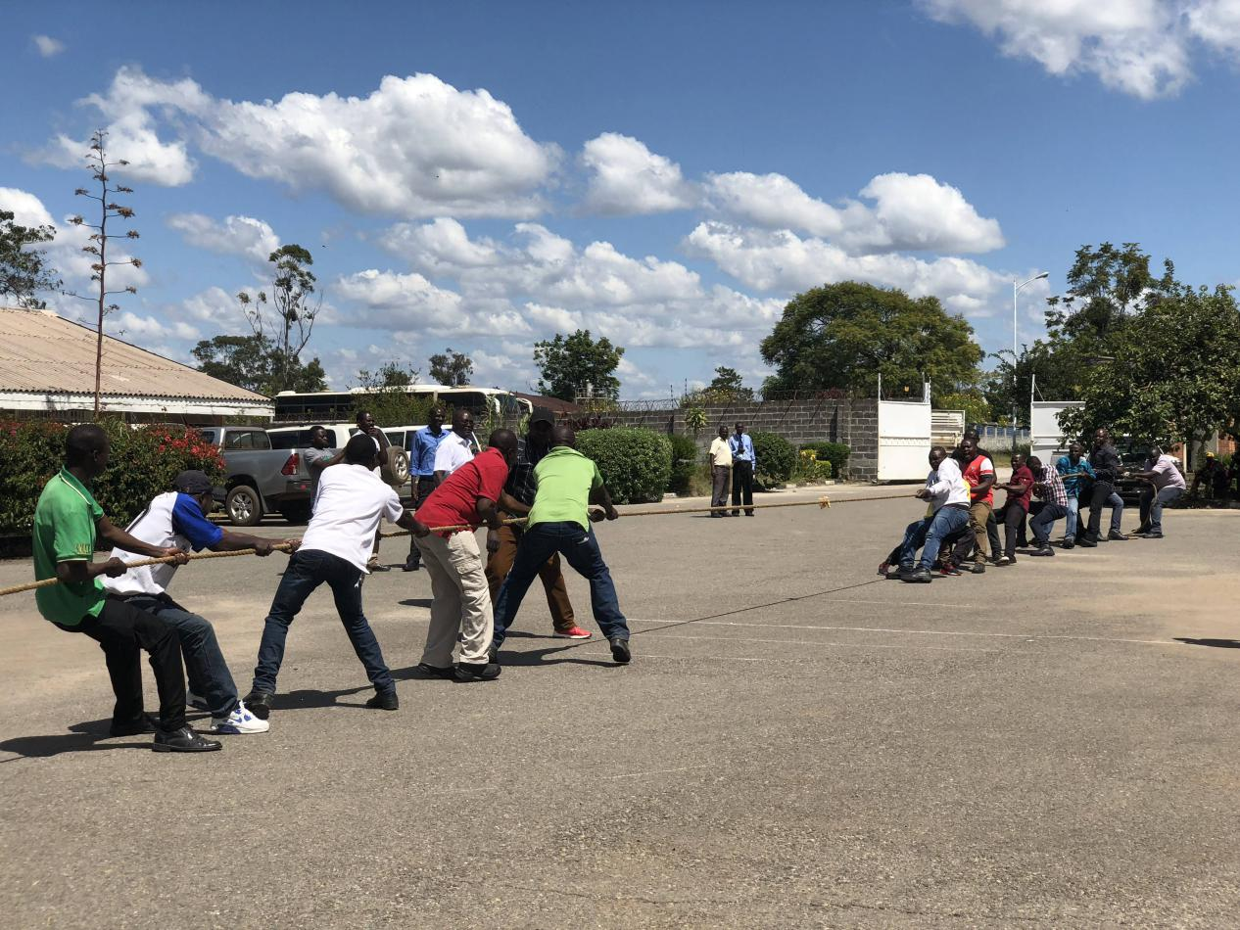

Tug-of-war

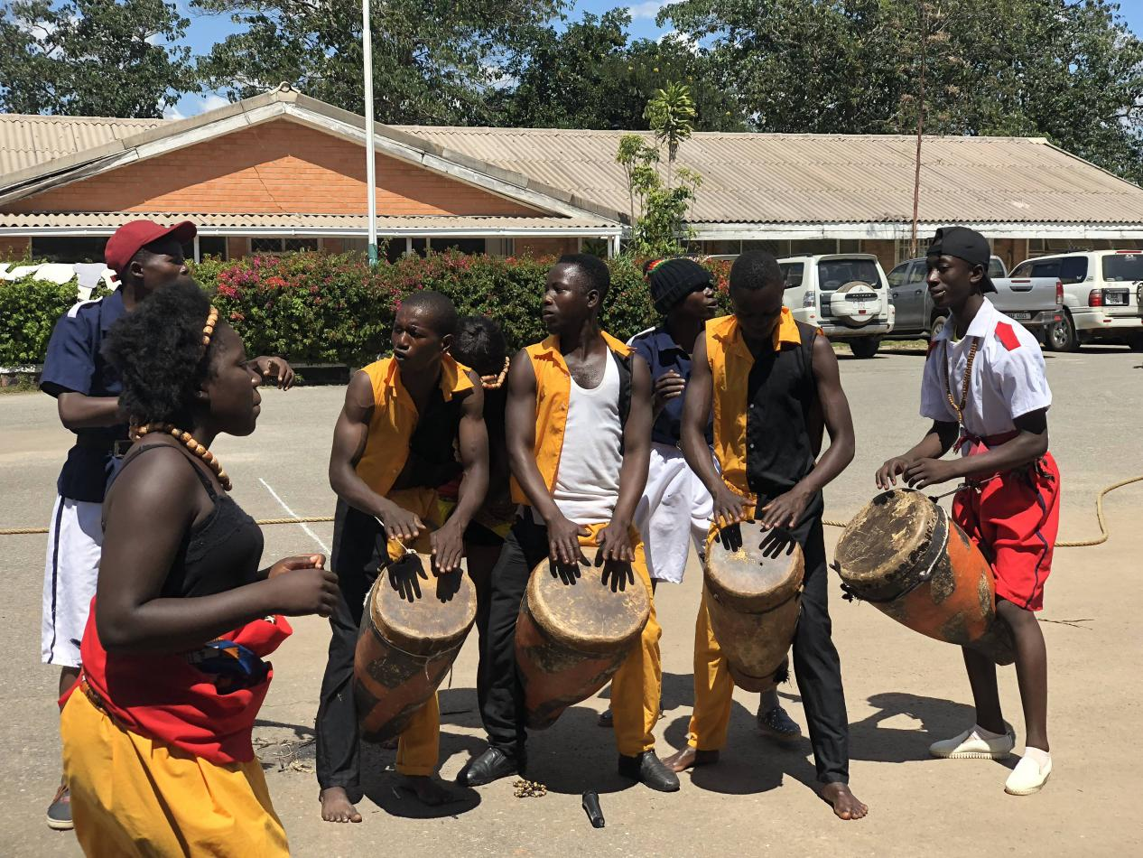

Zambia Pamodzi Art Troupe is offering excellent ethnic dance performance.

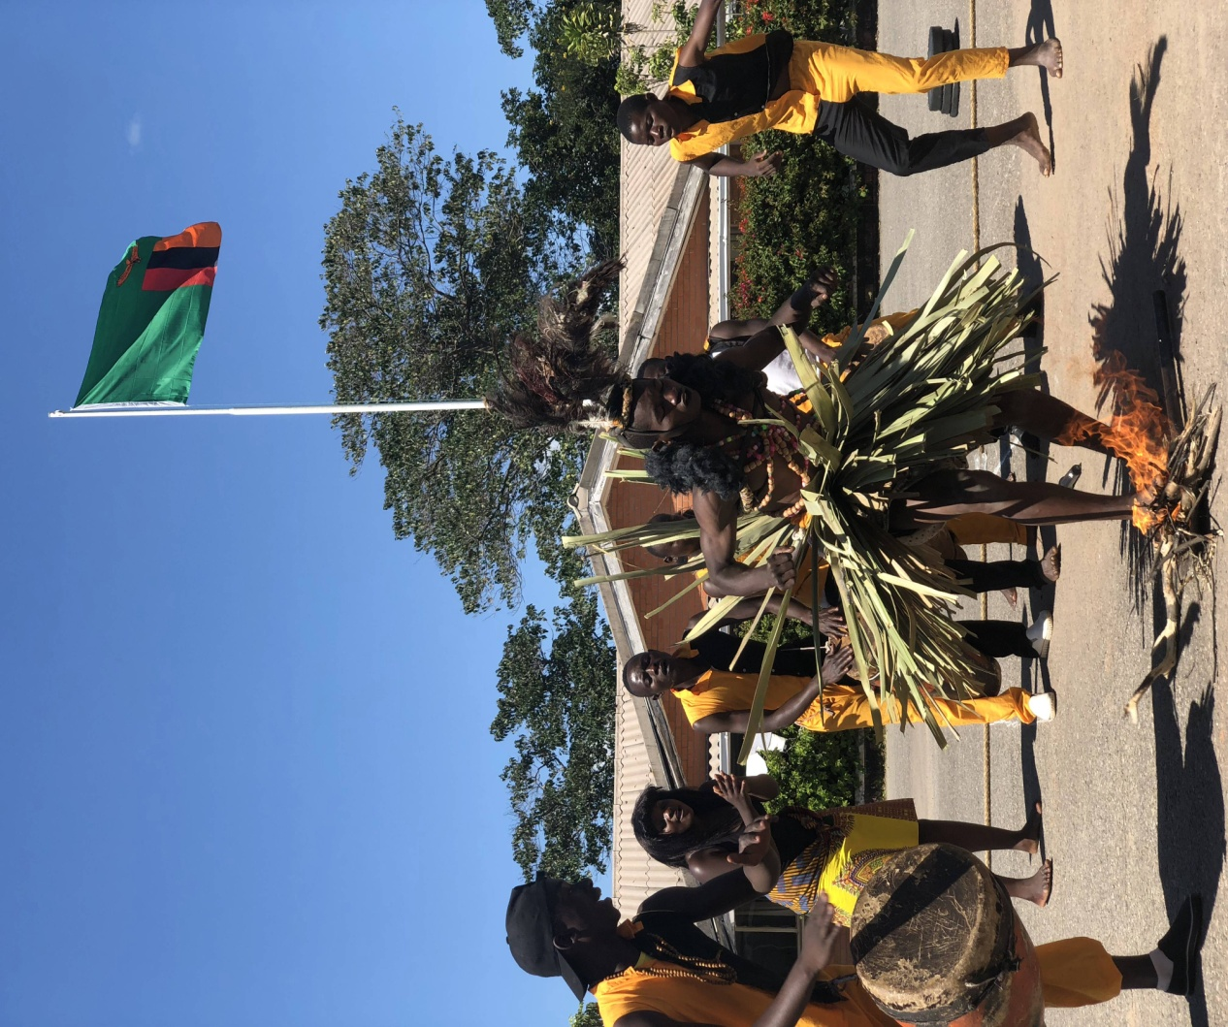

Zambia Pamodzi Art Troupe is offering excellent ethnic dance performance.

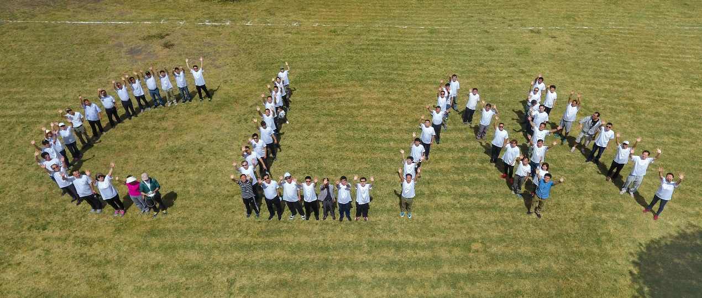

Sports meet scene of CNMC Luanshya